TC-CMS-036
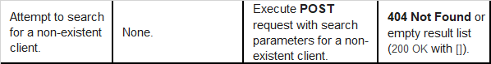
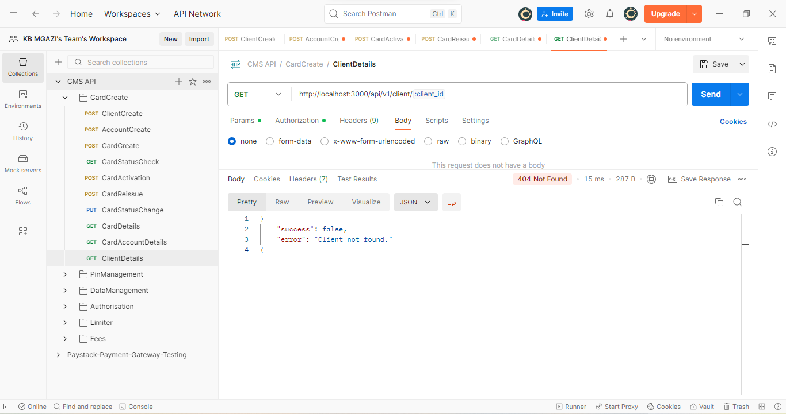
Response:
{
"success": false,
"error": "Client not found."
}

